Install Docker in device through Terminal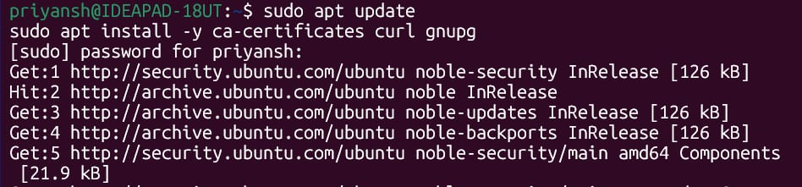
Add Docker GPG Key and Repo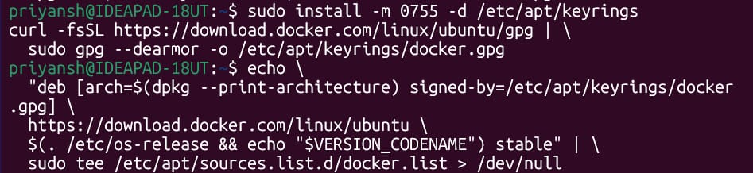
Run without sudo
Verify Installation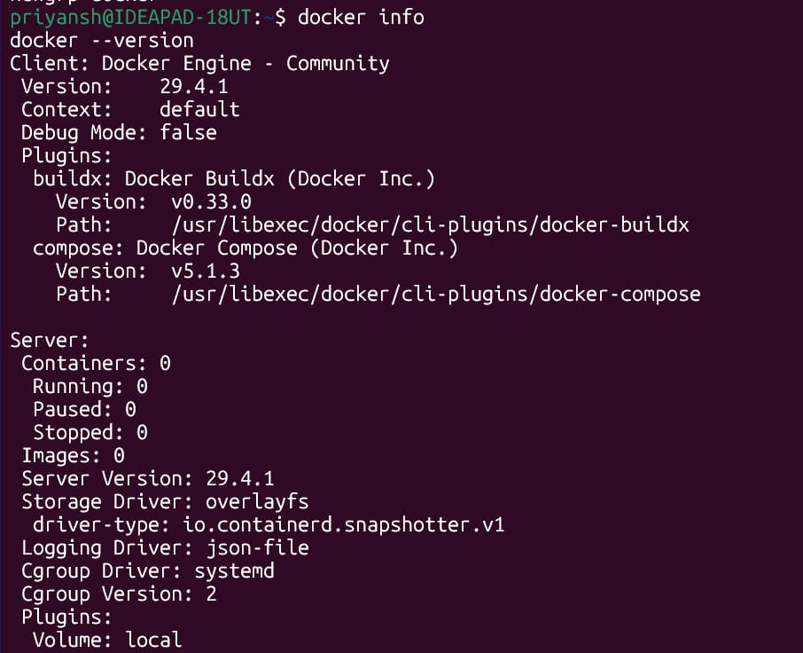
Pull and Run Official Images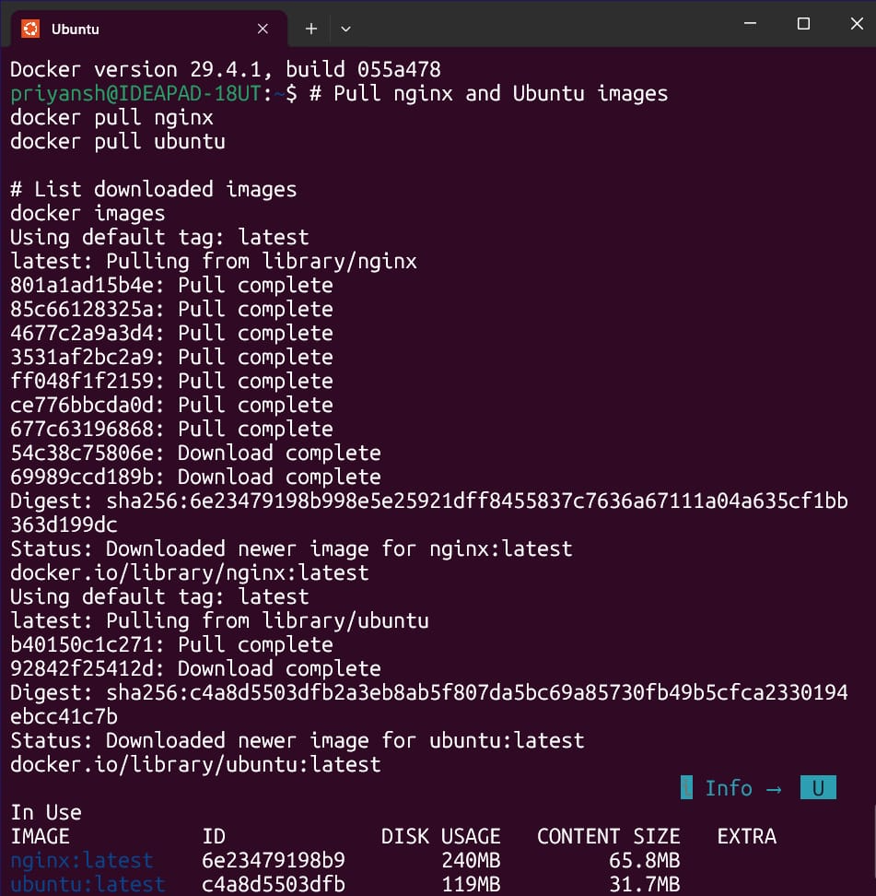
Run nginx container and explore it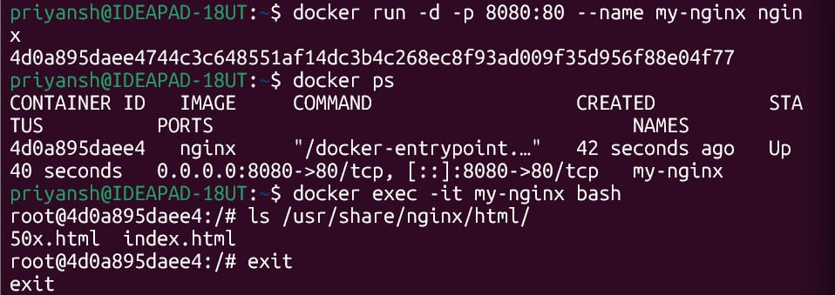
Stop Docker and remove it